MAKARSKA CUP 2019.
8th Tajmir Nola memorial tournament
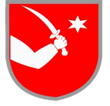

Makarska, 26th of October (Saturday)
Location: Gradska sportska dvorana, Franjevački put 2
Organisation: Judo club Biokovo Makarska

U10 – CHILDREN 2010, 2011, 2012
Boys -24, -27, -30, -34, -38, -42, -46, -50, +50
Girls -22, -25, -28, -32, -36, -40, -44, +44
U12 – YOUNGER BOYS AND GIRLS 2008, 2009
Boys -27, -30, -34, -38, -42, -46, -50, -55, +55
Girls -28, -32, -36, -40, -44, -48, -52, +52
U14 – OLDER BOYS AND GIRLS 2006, 2007 (points for Croatian Super Cup)
Boys -30, -34, -38, -42, -46, -50, -55, -60, -66, +66
Girls -32, -36, -40, -44, -48, -52, -57, -63, +63
U16 – YOUNGER MALE AND FEMALE CADETS 2004,2005 (joint locking and choking techniques allowed)
Younger male cadets -38, -42, -46, -50, -55, -60, - 66, -73, -81, +81
Younger female cadets -40, -44, -48, -52, -57, -63, -70, +70
U18 – MALE AND FEMALE CADETS 2002,2003 (joint locking and choking techniques allowed)
Male cadets -46, -50, -55, -60, -66, -73, -81, -90, +90
Female cadets -40, -44, -48, -52, -57, -63, -70, +70

VETERANS– 40 (1989. – 1980.), - 50 (1979. – 1970.), +50 (1969. and older)
Man -60, -66, -73, -81, -90, -100, +100
Woman -48, -52, -57, -63, -70, -78, +78

The competition starts at 10:15 AM and it will be held on four mats.
Participation fee: 80 HRK (10 €), double start: 120 HRK (15 €).
Competitors who can participate with a double start:
- Only older boys and girls from U12 category (born in 2008) can compete in older boys and girls U14 category
- Only older boys and girls from U14 category (born in 2006) can compete in younger male and female cadets U16 category
- All younger male and female cadets (born in 2004 and 2005) can compete in male and female cadets U18 category
Weight check schedule:
09.00 – 09.30 U10, U12
11.00 – 11.30 U14
13.30 – 14.00 U16
15.30 - 16.00 U18, VET

Fight duration: U10, U12 i U14 – 2 min., U16 – 3 min., U18 – 4 min., VET – 3 min.
Competition system: all groups get a double repechage, in categories where there are 5 or less competitors everyone competes against each other
Honours and awards:
- Medals for first, second and two third places
- Trophies for five most successful teams overall
- Trophies for most successful teams in each of the categories
- Awards for most successful competitors in each of the categories

Points system according to the rules of Croatian Judo Federation.

Contact information:
E-mail address: judobiokovo@gmail.com
Phone number: 098 9079 445 (Frane Puharić)

All Croatian clubs have to apply through the judo registry of Croatian Judo Federation. Competition will be held according to the rules of Croatian Judo Federation. Every competitor has to present a valid competition card with registration information and a confirmation of medical examination which must be no more than 6 months old during their weight check. Foreign competitors have to present a proof of identity (passport or identity card). The organiser will not be held responsible for the loss of personal items or injuries of the participants during the competition. All participants compete on the responsibility of their respective clubs.

Possibility of accomodation:
Hostel “ Yety “ - http://www.makarskahostel.com/hr/
Hostel " Makarska " - www.hostelmakarska.com

MAP OF MAKARSKA AND EVENT LOCATION:

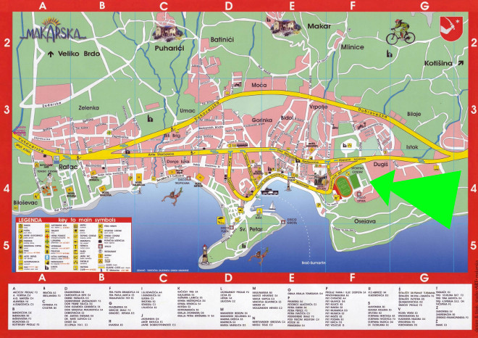
SEE YOU IN MAKARSKA!
www.judobiokovo.com
https://web.facebook.com/judobiokovo

